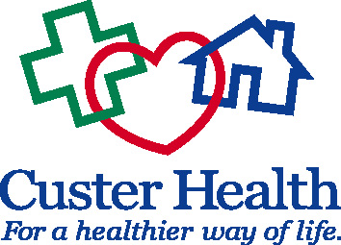
Custer Board of Health
Thursday, June 22nd
10 AM CST
Video Call/In Person

Call to order Dr. Grunseth

Preliminary 2024 Budget Meeting Agenda
- Review 2024 budget
- CD discussion regarding interest rate on $110,104.04 CD
- Upcoming meeting dates:
  - Joint Board of County Commissioners—August 15, 2023 10am CST
  - 2nd Quarter Board of Health meeting—September 14, 2023 2pm CST
Adjourn

Meeting Connection Information
______________________________________________________________________________
Microsoft Teams meeting
Join on your computer, mobile app or room device
Click here to join the meeting
Meeting ID: 223 235 049 073
Passcode: pgSyev
Download Teams | Join on the web
Or call in (audio only)
+1 872-242-8911,,433694087# United States, Chicago
Phone Conference ID: 433 694 087#
Find a local number | Reset PIN
Learn More | Meeting options
_____________________________________________________________________________

